grep Assignment

Mandatory:

1. Use any .c file. Using grep command extract and display

a. all lines beginning with #include with line numbers

🡺grep -n '^#include' assignment.c

This command will display all lines that begin with #include and show the line numbers

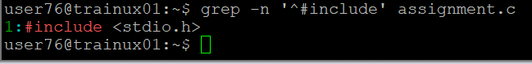

b. display all lines which do not begin with #include

🡺grep -n -v '^#include' assignment.c

This command will show all lines that do not start with #include and show the line numbers.

c. display the line number of main()

🡺grep -n 'main' assignment.c

This command will display the line number of the main() function.

d. extract all lines containing characters of opening and closing parathesis {(,)}

🡺grep -n '[(){},]' assignment.c

This command will display lines that contain any of the following characters: {, }, (, )

2. Performing the Above Operations on a Set of \*.c Files

a. All Lines Beginning with #include with Line Numbers

🡺grep -n '^#include' \*.c

b . Display All Lines Which Do Not Begin with #include

🡺grep -n -v '^#include' \*.c

c. Line Number of main():

🡺grep -n 'main(' \*.c

d. All Lines Containing {, }, (, ), or ,:

🡺grep -n '[(){},]' \*.c

